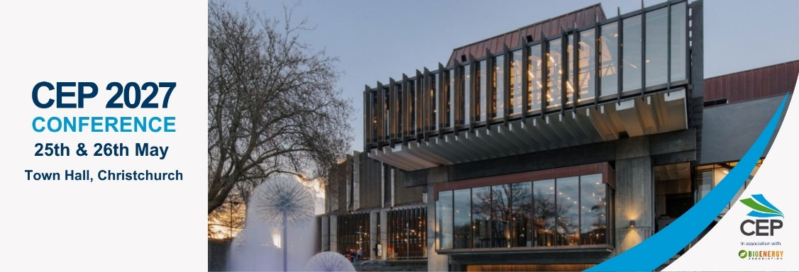
SUBMISSION TEMPLATE
The CEP review committee acknowledges not all sections below may be relevant to your proposed session. However, please complete them as fully as possible because your submission will be reviewed based on the content of the pages following.
Proposed session
Presentation | ☐ | Workshop | ☐
Submitter and Primary Contact
Organisation(s)
Presentation/Facilitation Team including job title
Session Title
Abstract (max 50 words)

The Challenge or Opportunity (max 50 words)
What energy, carbon, sustainability or related business challenge or opportunity does the presentation address?
Briefly describe the context and why the issue is relevant to practitioners working in New Zealand.
What Delegates Will Learn (max 50 words)
What specific knowledge, insights, methods or approaches will delegates gain from the presentation?
Focus on educational and informational content rather than general awareness or introductory material.
Approach, Method or Solution (max 50 words)
Explain the approach taken to address the challenge.
This could include a methodology, project, programme, technology, management approach, analysis, policy response, organisational change initiative or other practical intervention.
Results, Evidence and Lessons Learnt (max 50 words)
What were the outcomes?
Where possible, provide quantitative results, evidence, case-study findings or practical lessons. Include what worked, what did not, and any unexpected findings or challenges.

Practical Application (max 50 words)
How can delegates apply the knowledge or lessons from the presentation in their own organisations?
Highlight practical tools, processes, decision-making considerations, implementation insights, pitfalls to avoid, or other takeaways that will be useful to experienced practitioners.
Key Takeaways
Summarise 3–5 key takeaways delegates will leave with.
These should be specific and actionable, answering the question:
“What will an energy, carbon or sustainability practitioner know or be able to do differently after attending this session?”
If more than 1 presenter, please outline the specific contributions of each team member

Please submit to mike.hopkins@cep.org.nz by 17.00 on 30th October 2026.

