Template/Example

Measurement and Verification Report

For Client/Project

(Option C Small Project)

Document Control

Revision No. | Date | Author | Reviewed | Approved
0 | 1 April 2019 | Jack Smith | Jane Smith | John Smith

Contents
Document Control 1
1. Facility and Project Overview 3
Stakeholders and Project Team 3
Description of the Site/Facility 3
Project Description 3
M&V Requirements and Key Outcomes 3
2. ECM Intent 3
ECM Description: 3
Savings achieved by: 3
Affected Equipment: 3
Expected Savings: 3
3. IPMVP Option and Measurement Boundary 4
M&V Option: 4
Measurement Boundary: 4
Interactive Effects: 4
4. Baseline Definition 5
Period: 5
Energy Data: 5
Independent Variables: 6
Equipment Inventory 7
Static Factors: 7
5. Reporting Period Data Analysis and Savings Calculation 8
Period: 8
Frequency: 8
Measurements and Savings Calculation: 8
Non-Routine Adjustments 8
6. Energy Prices 8
Natural Gas: 8
7. Expected Accuracy 8
Appendix 1: Heating Degree Day Data – Base Temp Best Fit Calculation 11
Appendix 2: Heating Degree Day Data – Reporting Period 12

Facility and Project Overview

Stakeholders and Project Team | Client: ABC High School  Client Rep: Facilities Manager  Project Manager: Joe Blogs (Maintenance Eng)  M&V Specialist: Jack Smith (independent)
Description of the Site/Facility | Location: 123 Knowall Drive  Type: High School  Large school with a single hot water boiler supplying radiators for space heating throughout the school.  .
Project Description | Replace aging gas fired hot water boiler with more efficient condensing boiler.
M&V Requirements and Key Outcomes | Crown loan has been made available to fund the boiler replacement, and it is required to demonstrate that the annual energy savings exceed annual loan repayments of $15,000.

ECM Intent
ECM Description: | Replace existing boiler with more efficient condensing boiler.
Savings achieved by: | More efficient boiler uses less gas to meet the school heating demand (winter months only).
Affected Equipment: | - 1500 kW Gas Fired Boiler
Expected Savings: | 277,000 kWh ($15,000) per annum

IPMVP Option and Measurement Boundary
M&V Option: | Option C: Whole Facility  While gas is used for cooking in a couple of kitchen at the School, the Hot Water Heating boiler is the single largest gas consumer at the school by far. The more efficient boiler is expected to reduce school gas consumption by at least 25%.
Measurement Boundary: | The Gas Utility meter that supplies gas to the boiler and some other minor gas uses.
Interactive Effects: | There is no planned changes to the school heating demand and as such no interactive effects are anticipated..

Baseline Definition
Period: | The 12 month period of 1 April 2016 to 31 March 2017 (prior to the replacement of the boiler)
Energy Data: | Monthly gas consumption data was provided by the gas utility invoices as detailed in table 4.1 below:
Independent Variables: | - Heating Degrees Days – as provided by a local weather station (via www.degreedays.net). The monthly HDDs for a range of base temperatures were obtained and the RSQR() function in excel was used to determine the base temperature that correlated the best with the Gas Consumption. The HDD base Temperature of 19.5 deg C was determined to have the best fit (refer Appendix 1 for details).  - Number of teaching days each month is expected to have a significant impact on gas consumption.  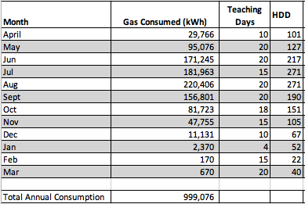  Table 4.1: Baseline Energy and Independent Variable Data  For the summer months (Dec – Mar) when the boiler doers not operate, the baseline will be the actual consumption of the small uses (i.e. kitchens) at the school.  For the months when the boiler does operate (April – Nov), the LINEST function in Excel was used to determine the regression model (and associated standard errors) for relationship between school gas consumption and the independent variables.  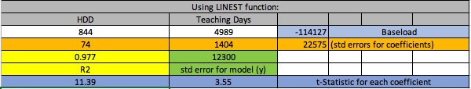  There the monthly school gas consumption model is:  Monthly Gas Use = 844 * HDD + 4989 * Teaching Days – 114127 kWh  The outputs from the LINEST Function were also used to determine the validity of this multivariate regression model:  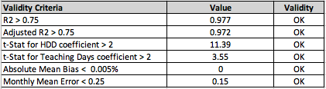
Equipment Inventory | - 1 x 1500 kW gas fired Boiler
Static Factors: | - Boiler hot water return temperature set point of the return heating water temperature to the boiler.  - The radiator heating capacity (should be changes be made to radiator configuration).

Reporting Period Data Analysis and Savings Calculation
Period: | 12 months post installation of the new boiler.
Frequency: | Monthly.
Measurements and Savings Calculation: | Table 5.1 below details the measurements recorded for the 12 month post installation period along with calculated savings:  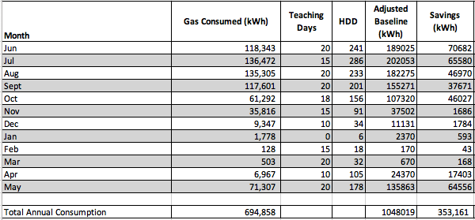  (refer Appendix 2 for HDD data file).  As can been seen above the savings calculated by deducting the actual gas consumption from the adjusted baseline for each month are 353,161 kWh for the 12 month period.  The value of these savings is therefore:  273,180 kWh x 5.4 c/kWh = $ 19,071 per annum exceeding the expected energy savings of $15,000 per annum.
Non-Routine Adjustments | There were no changes recorded of any of the static factors identified, for the baseline and reporting periods, and not defects reported. As such non non-routine adjustments were required to be made to the calculated savings.

Energy Prices
Natural Gas: | Blended rate of 5.4 cents per kWh to be used for the valuation of all energy savings.

Expected Accuracy

Required level of Accuracy and Precision | Results to be reported with 90% probability (confidence) and ±20% precision
Metering equipment measurement standard error calculation | The Gas Utility Meter is assumed to be 100% accurate.  The Heat Degree Day data publicly published and assumed to be 100% accurate.  The schools teaching day data in also published on-line and assumed to be 100% accurate.
Sampling Error Calculation | No sampling performed.
Modelling Uncertainty Calculation | As detailed in the Baseline development (refer Section 4) , the LINEST function in Excel was also used to determine the standard error of the baseline energy model to be 12,300 kWh.
Savings Assessment Uncertainty Calculation | Savings Assessment Uncertainty Formula:  $${SE}_{monthly savings}=\sqrt{{{(SE}_{baseline})}^{2}+{{(SE}_{Reporting })}^{2}}$$  For the months of April to November:  $${SE}_{monthly savings}=\sqrt{{(12,300)}^{2}+{(0)}^{2}}=12,300 kWh$$  For the months of December to March:  $${SE}_{monthly savings}=\sqrt{{(0)}^{2}+{(0)}^{2}}=0 kWh$$  Note SE_{reporting} is 0 as the actual measurements are provided by a utility meter which is assumed to be 100% accuarate.  Hence the the standard error of the annual savings is:  ${SE}_{annual savings}=\sqrt{{(12,300)}^{2} x 8 months}=34,790 kWh$  To calculate the confidence interval for the estimated savings ($\hat{x}$):  - $\hat{x}-t∙SE\left(\hat{x}\right)≤x≤\hat{x}+t.SE(\hat{x})$  where:  - Absolute Precision $\left(\hat{x}\right)=t∙SE(\hat{x})$ = 2.02 x 34,790 = 70,275  - Relative Precision $\left(\hat{x}\right)=\frac{t∙SE(\hat{x})}{(\hat{x})}= \frac{70,275}{353,161}=19.9\%$  and: t is the t-value for (n-k-1) degrees of freedom  where:  n = 8 (monthly samples)  k = no. coefficients In baseline model = 2  Thus the calculated energy savings are 353,161 ± 70,275 kWh (20 %) with a 90% confidence level.

Appendix 1: Heating Degree Day Data – Base Temp Best Fit Calculation

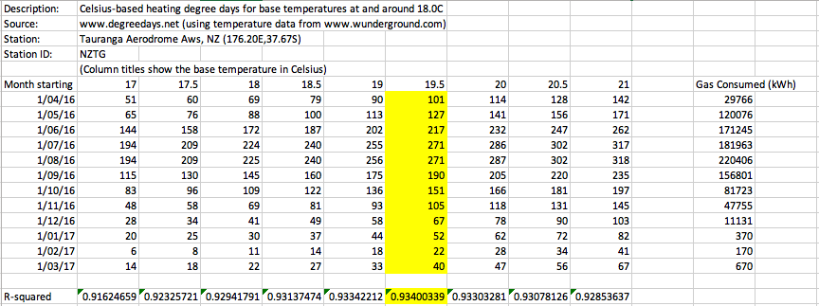

Appendix 2: Heating Degree Day Data – Reporting Period

