Template/Example

Measurement and Verification Report

For Client/Project

(Option B Small Project)

Document Control

Revision No. | Date | Author | Reviewed | Approved
0 | 1 April 2019 | Jack Smith | Jane Smith | John Smith

Contents
Document Control 1
1. Facility and Project Overview 4
Stakeholders and Project Team 4
Description of the Site/Facility 4
Project Description 4
M&V Requirements and Key Outcomes 4
2. ECM Intent 4
ECM Description: 4
Savings achieved by: 4
Affected Equipment: 4
Expected Savings: 4
3. IPMVP Option and Measurement Boundary 5
M&V Option: 5
Measurement Boundary: 5
Interactive Effects: 5
4. Baseline Energy Model 6
Period: 6
Energy and Independent Variable Data: 6
Model Development 7
5. Reporting Period Data Analysis and Savings Calculation 8
Period: 8
Frequency: 8
Measurements: 8
Saving Calculation: 8
6. Energy Prices 9
Electricity: 9
7. Meter Specifications 9
Electrical sub Meter: 9
Meter Reading and Witnessing protocol 9
Lost measurements record plan 9
8. Monitoring Responsibilities 9
Operational Verification: 9
Collecting Energy Data: 9
Collecting Independent Variable Data: 9
Collecting Static Factors: 9
Analysing collected data: 9
Reporting Savings: 9
9. Expected Accuracy 9

Facility and Project Overview
Stakeholders and Project Team | Client: Food Manufacturer  Client Rep: Plant Manager  Project Manager: Joe Blogs (Refrigeration Eng)  M&V Specialist: Jack Smith (independent)
Description of the Site/Facility | Location: 123 Smith Drive  Type: Food Manufacturing Plant  - Large refrigeration system to store a frozen food line  - Refrigeration System has a number of compressors controlled be an aging step logic control system.
Project Description | Replace aging step logic control system with PLC System to regulate the loading and unloading of refrigeration compressors.
M&V Requirements and Key Outcomes | The Plant Manager is required to demonstrate that the ROI will be achieved within 5 years (with 90% probability).

ECM Intent
ECM Description: | Upgrade refrigeration control system.
Savings achieved by: | Reduce un-necessary run time of compressors.
Affected Equipment: | - Step Logic Controlled Refrigeration System  - Consumes 1,240,330 kWh (last 12 month)
Expected Savings: | 154,000 kWh ($20.000) per annum

IPMVP Option and Measurement Boundary
M&V Option: | Option B: All Parameter Measurement
Measurement Boundary: | Electrical supply to refrigeration system which powers evaporator and condenser fans, compressors and controls.
Interactive Effects: | Nil.

Baseline Energy Model
Period: | A four week period was sufficiently long enough period to observe all operating condition (i.e. production) variances.
Energy and Independent Variable Data: | Daily energy consumption and operational hours of the refrigeration system was recorded via check meter installed prior to baseline period. The Cooling degree days were obtained from the degreedays.net web portal. The following table details the findings:  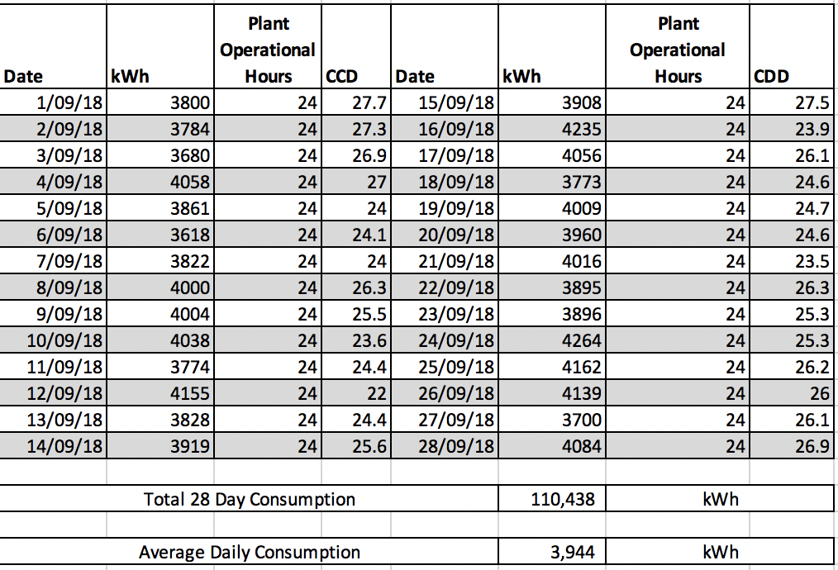
Model Development | It was expected that there would be a reasonable correlation of between the daily energy consumption and the daily CDD. As can be seen in the following regression analysis, the correlation was not good (with and r-squared value 0.02:  No other independent variables were expected to have a correlation with daily energy consumption, apart from plant operating hours (which were consistently 24 hours for the Baseline period). Therefore the baseline model was determined to be the average daily consumption of the refrigeration system for the 28 day period i.e. 3,944 kWh.

Reporting Period Data Analysis and Savings Calculation
Period: | A four week period to match the baseline period.
Frequency: | Continuous logging of refrigeration system electrical energy consumption.
Measurements: | Daily energy consumption of the refrigeration system for the reporting period was recorded as detailed in the following table:  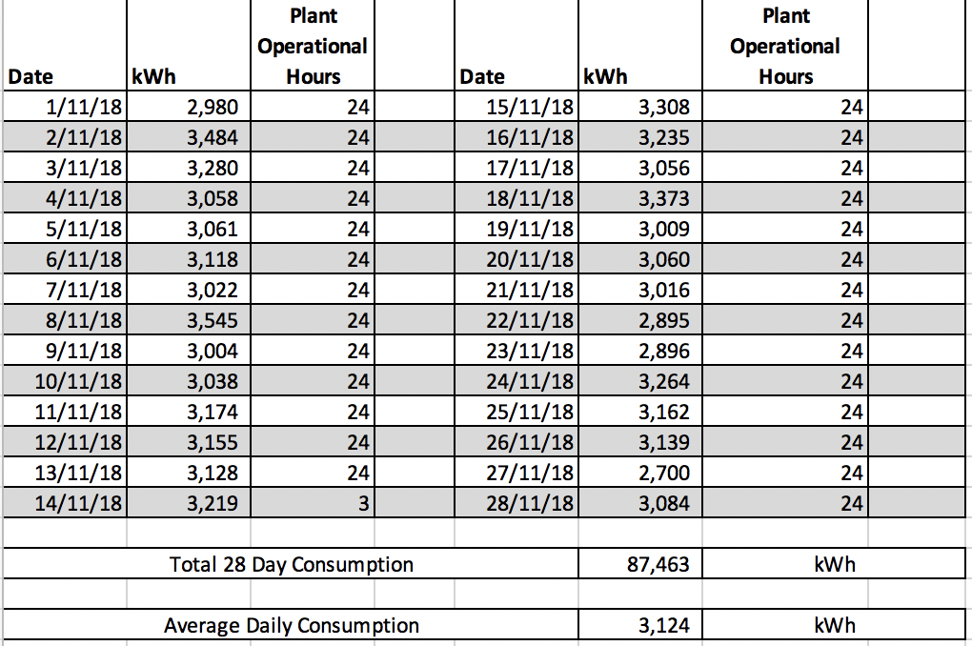
Saving Calculation: | Energy Savings are calculated using the following equation:  kWh_{savings} = (average daily kWh_{base} – average daily kWh_{reporting}) x 28 days ± adjustments  kWh_{savings} = (3944 – 3124)kWh x 28 days = 22,960 kWh  Annualised saving = 299,300 kWh  The value of the savings for the reporting period is therefore:  22,960 x 0.13 c/kWh = $2,984.80  Extrapolating these savings to an annual total of $38,909 exceeding the expected annual savings of $20,000.  With the project cost of $145,636, the simple payback period for the project was under four years.

Energy Prices
Electricity: | Blended rate of 13 cents per kWh to be used for the valuation of all energy savings

Meter Specifications
Electrical sub Meter: | Merlin Gerin PM800 kWh
 | Meter Accuracy = ±1%
Meter Reading and Witnessing protocol | Not applicable.
Lost measurements record plan | Meter energy data will be uploaded on a weekly basis. Should any data be lost during any given week then the baseline or reporting periods will be extended for a further week to ensure lost data does not impact on the savings assessment.

Monitoring Responsibilities
Operational Verification: | Joe Blogs (Project Manager)
Collecting Energy Data: | Joe Blogs (Project Manager)
Collecting Independent Variable Data: | Jack Smith (M&V Specialist)
Collecting Static Factors: | Joe Blogs (Project Manager)
Analysing collected data: | Jack Smith (M&V Specialist)
Reporting Savings: | Jack Smith (M&V Specialist)

Expected Accuracy
Required level of Accuracy and Precision | Results to be reported with 90% probability (confidence) and ±10% precision
Metering equipment measurement standard error calculation | $${SE}_{metering}=\frac{meter relative precision∙measured value}{t}$$  Where t = t-statistic for infinite sample sizes  Energy Meter Accuracy = ±1%.  At the required 90% confidence level the Standard Error of measurement by this meter will be calculated as:  $${SE}_{metering} =\frac{0.01∙kWh}{1.645}=0.006 {kWh}_{}$$  Where 1.645 is the t-value @ 90% confidence
Sampling Error Calculation | Baseline Period:  Number of samples (n) = 28 daily kWh totals.  Sampling Standard Error Calculation using the following equations:  - Sample Mean: $\overline{Y} =\frac{\sum{Y_{i}}}{n}=3944 kWh$  - Sample Variance: $s^{2}=\frac{{\sum{(Y_{i}-}\overline{Y})}^{2}}{n-1}=28,495$  - Sample Standard Deviation: $s= \sqrt{s^{2}}=169 kWh$  - Standard Error of Mean: ${SE}_{sample} =\frac{s}{\sqrt{n}}=31.9 kWh$  Reporting Period:  Number of samples (n) = 28 daily kWh totals.  Sampling Standard Error Calculation using the following equations:  - Sample Mean: $\overline{Y} =\frac{\sum{Y_{i}}}{n}=3124 kWh$  - Sample Variance: $s^{2}=\frac{{\sum{(Y_{i}-}\overline{Y})}^{2}}{n-1}=31,623$  - Sample Standard Deviation: $s= \sqrt{s^{2}}=177 kWh$  - Standard Error of Mean: ${SE}_{sample} =\frac{s}{\sqrt{n}}=33.6 kWh$
Modelling Uncertainty Calculation | As the baseline model was determined to be the actual daily kWh measurements, there is no modelling error to calculate.
Savings Assessment Uncertainty Calculation | Savings Assessment Uncertainty Formula:  $${SE}_{daily savings}=\sqrt{{{(SE}_{baseline})}^{2}+{{(SE}_{Reporting })}^{2}}$$  Where:  $${SE}_{baseline}=\sqrt{{{(SE}_{sampling})}^{2}+ {{(SE}_{Measurement})}^{2}+{{(SE}_{Modelling})}^{2}}$$  $${SE}_{baseline}=\sqrt{{(31.9)}^{2}+ {(0.006)}^{2}+{(0)}^{2}}=31.9 kWh$$  $${SE}_{reporting}=\sqrt{{{(SE}_{sampling})}^{2}+ {{(SE}_{Measurement})}^{2}+{{(SE}_{Modelling})}^{2}}$$  $${SE}_{reporting}=\sqrt{{(33.6)}^{2}+ {(0.006)}^{2}+{(0)}^{2}}=33.6 kWh$$  Therefore:  $${SE}_{daily savings}=\sqrt{{(31.9)}^{2}+{(33.6)}^{2}}=46.3 kWh$$  And the Annual Savings Standard Error is calculated to be:  $${SE}_{annual savings}=\sqrt{ 365 X {(46.3)}^{2}}=885.1 kWh$$  To calculate the confidence interval for the estimated savings ($\hat{x}$):  - $\hat{x}-t∙SE\left(\hat{x}\right)≤x≤\hat{x}+t.SE(\hat{x})$  where:  - Absolute Precision $\left(\hat{x}\right)=t∙SE(\hat{x})$ = 1.70 x 885.1 = 1,504 kWh  - Relative Precision $\left(\hat{x}\right)=\frac{t∙SE(\hat{x})}{(\hat{x})}= \frac{1,504}{299,300}=0.5\%$ =  And “t” is the t-value for 27 (n-1) degrees of freedom = 1.70  Therefore the estimated annual savings can be stated to be 299,300 kWh ± 1,504 kWh with a 90% probability.

