Template/Example

Measurement and Verification Report

For Client/Project

(Option A Small Project)

Document Control

Revision No. | Date | Author | Reviewed | Approved
0 | 1 April 2019 | Jack Smith | Jane Smith | John Smith

Contents
Document Control 1
1. Facility and Project Overview 3
Stakeholders and Project Team 3
Description of the Site/Facility 3
Project Description 3
M&V Requirements and Key Outcomes 3
2. ECM Intent 3
ECM Description: 3
Savings achieved by: 3
Affected Equipment: 3
Expected Savings: 3
3. IPMVP Option and Measurement Boundary 4
M&V Option: 4
Measurement Boundary: 4
Interactive Effects: 4
4. Baseline Definition 5
Period: 5
Key Parameter Measurements: 5
Estimated Parameters: 5
Static Factors: 5
5. Reporting Period Data Analysis and Savings Calculation 6
Period: 6
Frequency: 6
Measurements and Savings Calculations: 6
6. Basis for Adjustment 6
Conditions 6
Routine Adjustments 6
Non-routine Adjustments 6
7. Energy Prices 7
Electricity: 7
8. Expected Accuracy 7

Facility and Project Overview

Stakeholders and Project Team | Client: Government Agency Regional Office  Client Rep: Office Manager  Project Manager: Lighting Contractor  M&V Specialist: Jack Smith (independent)
Description of the Site/Facility | Location: 123 Smith Drive – Level 2  Type: Tenancy of Commercial Building  - Open plan space  - Regular Office hours  - Air Conditioning supplied from Central plant
Project Description | Replace existing T8 Florescent lighting fittings with LED Tubes throughout open plan office area.
M&V Requirements and Key Outcomes | The proposal for the lighting upgrade from the lighting contractor included a guarantee that the energy cost savings from the LED upgrade would provide a simple payback period of less than four years. This was to be verified independently.

ECM Intent
ECM Description: | Replace existing T8 Florescent lighting fittings with LED Tube fittings throughout open plan office area.
Savings achieved by: | Reduced electricity consumption and demand costs.
Affected Equipment: | All existing T8 Lighting troffers
Expected Savings: | Energy and Demand savings of ($3000) per annum.

IPMVP Option and Measurement Boundary
M&V Option: | Since weekly office hours were very regular, the available budget for the project was small and the technical risk of not achieving the guaranteed savings was low, Option A: Key Parameter Measurement was selected.
Measurement Boundary: | 10 lighting circuits on the Tenancy distribution board.
Interactive Effects: | Since the air conditioning was supplied form the landlord controlled central plant, the tenant is does not benefit from any central plant operating cost reductions, the interactive effects of reduced cooling load and increased heating demand from the LED upgrade was ignored.

Baseline Definition
Period: | Prior to the replacement of the lighting, a one off period of 30 minutes during normal office hours when all lighting circuits are turned on.
Key Parameter Measurements: | The power draw of each lighting was to be measured by a registered electrician at the Tenancy Distribution Board:  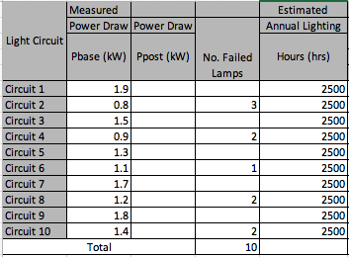
Estimated Parameters: | The Office Manager advised that the office was typically occupied from 8AM to 6PM, 5 days per week and for 50 weeks of the year. Hence the estimated annual operating hours of the lighting circuits is 2500 hours
Static Factors: | It was noted that there were 10 failed T8 Florescent tubes across a number of the lighting circuits at the time that the baseline power measurements were taken.

Reporting Period Data Analysis and Savings Calculation
Period: | Immediately after the replacement of the lighting, a one off period of 30 minutes during normal office hours when all lighting circuits were turning on.
Frequency: | Once.
Measurements and Savings Calculations: | Electrical power draw of each lighting circuit was measured at the tenancy switch board and resulted in the following energy and demand saving calculations:  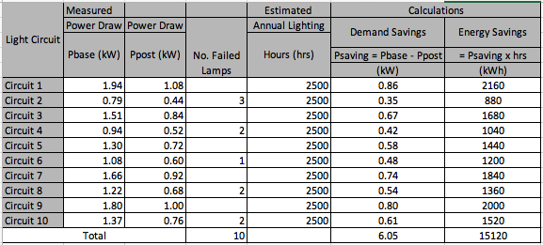

Basis for Adjustment
Conditions | There are no condition changes that impact on the verified energy saving and as such the verified results are independent of the prevailing conditions during the baseline and reporting periods.
Routine Adjustments | No adjustments required.
Non-routine Adjustments | Should any lamps be found to be failed during the baseline measurement period, than the measure power reduction for the respective lighting circuit will be adjusted using the following calculations:  - Energy Savings Adjustment = 10 failed lamps x 32/1000 kW x 2500 hours = 800 kWh  - Demand Savings Adjustment = 10 failed lamps x 32 watts/1000 kW  Hence Energy and Demand savings are adjusted to:  - Annual Energy Savings = 15,120 + 800 = 15,920 kWh  - Demand Savings = 6.05 + 0.32 = 6.37 kW

Energy Prices
Electricity: | Blended rate of 18 cents per kWh to be used for the valuation of all energy savings:  Therefore Annual Energy Cost Savings = 15,920 x 0.18 = $2,865.20  Fixed rate of $4/kW per month for all demand savings.  Therefore the Annual Demand Cost Savings = 6.37 x 4 x 12 = $305.76  And so total savings are estimated to be $3,171 per annum.

Expected Accuracy

Required level of Accuracy and Precision | Results to be reported with 90% probability (confidence) and ±10% precision
Metering equipment measurement standard error calculation | $${SE}_{metering}=\frac{meter relative precision∙measured value}{t}$$  Where t = t-statistic for infinite sample sizes  Power Meter Accuracy = ±1%.  At the required 90% confidence level the Standard Error of measurement by this meter will be calculated as:  $${SE}_{metering} =\frac{0.01∙kWh}{1.645}=0.006 {kWh}_{}$$  Where 1.645 is the t-value @ 90% confidence  However for the purposes of this small project, and as the metering standard error is so small, the metering error is ignored.
Sampling Error Calculation | The power draw on all lighting circuits are being measured and therefore no sampling related uncertainty applies.
Modelling Uncertainty Calculation | No modelling was undertaken therefore modelling uncertainty is not calculated.
Savings Assessment Uncertainty Calculation | Savings Assessment Uncertainty Formula:  $${SE}_{daily savings}=\sqrt{{{(SE}_{baseline})}^{2}+{{(SE}_{Reporting })}^{2}}$$  Where:  $${SE}_{baseline}=\sqrt{{{(SE}_{sampling})}^{2}+ {{(SE}_{Measurement})}^{2}+{{(SE}_{Modelling})}^{2}}$$  $${SE}_{reporting}=\sqrt{{{(SE}_{sampling})}^{2}+ {{(SE}_{Measurement})}^{2}+{{(SE}_{Modelling})}^{2}}$$  As the only error to consider is the metering error which is very small compared with magnitude of the savings, no futher uncertainty assessment is required, and the estimated savings are considered to be 100% accurate.

